**CASE STUDY**

**PROJECT NAME: SIDE SLOPE PROTECTION FOR**

**AL-KHAD - SHAM ROAD IN SUHAR**

**The following is a case study for the above-mentioned project where Marmol Integrated LLC was able to apply better slope protection solutions applying value engineering and thus, minimised the cost for application of slope protection.**

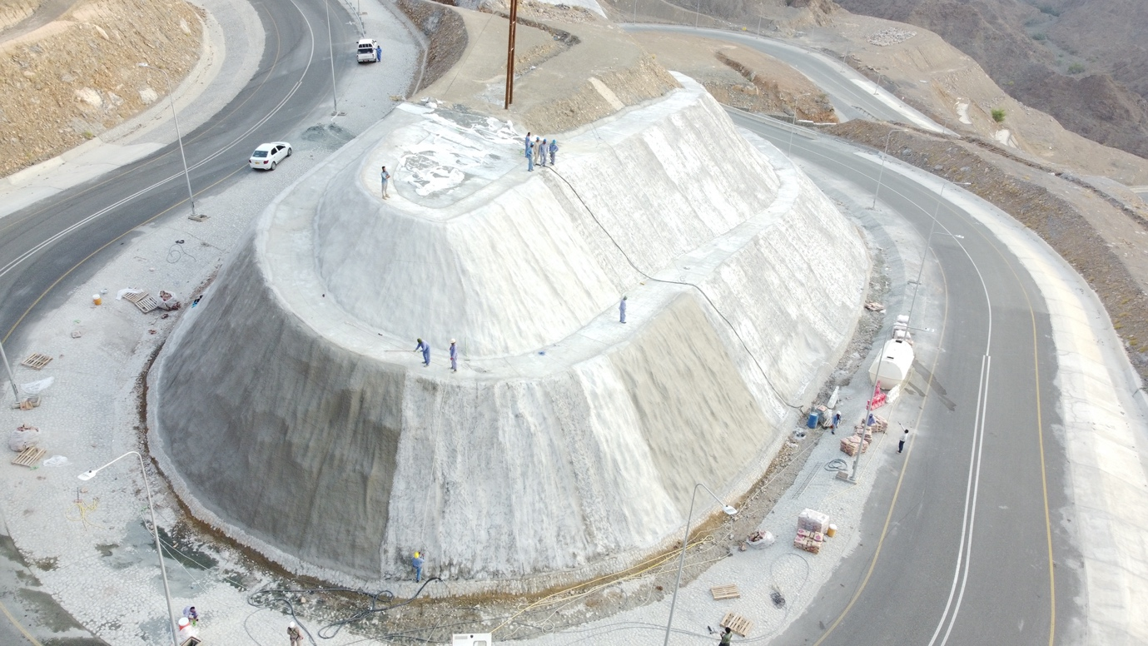

|  |  |
| --- | --- |
| Project Name: | Side Slope Protection for Al-Khad -Sham Road in Suhar |
| Location: | **Sohar** |
| Client: | **Sohar Municipality** |
| Main Contractor: | **Marmol Integrated LLC** |
| Scope of Work: | **Topographic Survey, Slope Stability Analysis and Slope Protection Work** |

**PROJECT DETAILS**

|  |
| --- |
| **Background** |

**The project location is a 7km stretch of road connecting the villages of Al-Khad and Sham going through several mountains. The clients original project completion date was 2016 where it was part of the road contract. Hence a side slope protection design was proposed and cutting of the mountain was already implemented. However, the project didn’t continue due to several issues and was consequently abandoned, with the already cut mountains exposed to rain and wind unprotected.**

**After several years, the slope protection part was reopened for completion. The client took prices from the competent contractors after site visit. The contractors were incharge of the protection systems installation as per the 2016 drawings on the current site conditions. The design and supervision consultant was retained for the proper execution of the job.**

|  |
| --- |
| **Challenges** |

* **The original project drawings and design parameters did not match the site anymore because of the instabilities and damages to the slope due to years of erosion of the exposed surface.**
* **Several areas had caved in and additional earthworks were required to restore the geometry.**
* **A new design was required with no additional budget for design.**
* **Several caved areas and parts of the mountain were inaccessible and hence an accurate estimate of the current state was deemed impossible.**
* **Constant rain in the area was a challenge to any work plans as prepared area was being eroded even during the execution of the project.**
* **A traditional shotcrete system was going to be difficult due to the lack of access and availability of concrete plants nearby.**

|  |  |
| --- | --- |
| **Benefits for the Clients** | **Background** |

* **Achieved a savings of upto 500,000 OMR for client. This was compared to the system proposed in the tender documents as quoted by the competitors and found that the traditional shotcrete system was quoted at higher price by other contractors due to the challenging terrain. Marmol Integrated proposed the ConstruckSlope Slope Protection and Erosion Systems from Germany that provided better performance.**
* **Marmol proposed to do a new value engineered design at no extra cost to client with the approval of the consultant to make a design better suited for the conditions.**
* **A total re-survey was completed with 3D modeling allowing the client to access and view the challenging areas of the site.**
* **Client was invited to experience the production and quality parameters at the factories in Germany.**

|  |  |
| --- | --- |
| **How We Achieved It** | **Background** |

|  |  |
| --- | --- |
| **Pictures** | **Background** |

|  |
| --- |
| **Products Used and its Origin** |